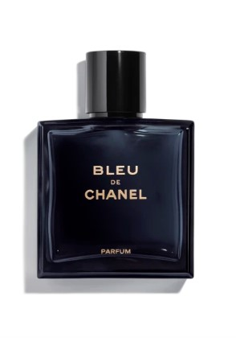**** **BLEU DE CHANEL**

**product**

The most intense of the BLEU DE CHANEL fragrances. Powerful and refined, the Parfum for men reveals the essence of independence and determination. A timeless scent with a strong masculine signature.

**composition**

An invigorating freshness opens, lingering on the warm fullness of cedar and New Caledonian sandalwood that sweeps throughout the intense, aromatic-woody accord, leaving a captivating trail.

**art of perfuming**

The Parfum comes in a spray for easy application.